**Colegio Sol de Chile**

**Lo Espejo- Santiago**

**Departamento de Inglés**

**Miss Yancarla Taibe Q.**

[Miss.yancarla@gmail.com](mailto:Miss.yancarla@gmail.com)

|  |
| --- |
| **ENGLISH HANDOUT 1** |

|  |
| --- |
| **Name:** |
| **Grade: I° Medio** |
| **Date:** |
| **E-mail o Red Social:** |
| **Nombre y Teléfono de contacto (Apoderado)** |

|  |  |
| --- | --- |
| **Instrucciones:**   * Recuerda anotar tu nombre en el recuadro anterior * Lee atentamente las instrucciones * Recuerda que me puedes contactar en [miss.yancarla@gmail.com](mailto:miss.yancarla@gmail.com) si es que tienes alguna duda o consulta * Si tienes guías pendientes por favor lleva las al colegio cuando se indique * Desarrolla la guía con lápiz pasta negro o azul. * Puedes usar diccionario silo necesitas. | |
| **Objetivos:** OA 14: Escribir una variedad de textos breves, como cuentos ,correos electrónicos, folletos, rimas, descripciones, biografías, instrucciones y resúmenes, utilizando los pasos del proceso de escritura (organizar ideas, redactar, revisa, editar, publicar) ocasionalmente con apoyo, de acuerdo a un modelo y a un criterio de evaluación ,recurriendo a herramientas como el procesador de textos y diccionario en línea  **-Indicadores:**  Describen hábitos pasados  Escriben textos variados.  .**-Contenido:** Past simple, verbos regulares e irregulares .y números 1 al 1000  **-Habilidad o Eje del idioma:** Writing and reading  **-Procedimental:** Aplicar y utilizar el Presente simple en todas sus formas  **-Actitudinal:** Demostrar respeto ante otras personas, realidades o culturas, reconociendo sus aportes y valorando la diversidad de modos de vida. |

**Warm Up:**

What do you like to do WHEN YOU GROW UP? Why?

_______________________________________________________________

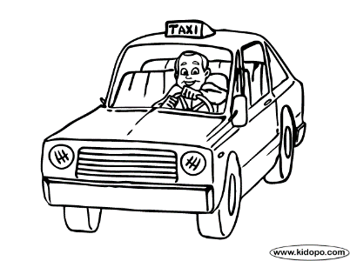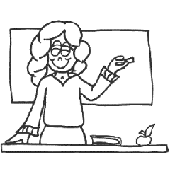

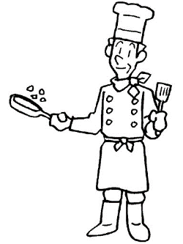

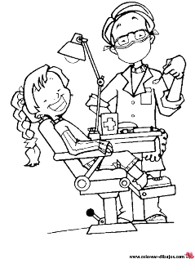

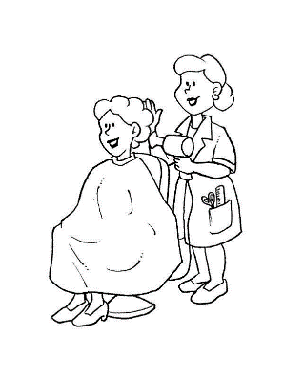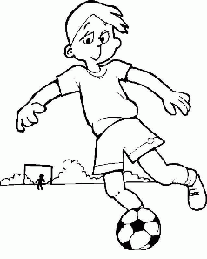

**Process**

Vocabulary

|  |
| --- |
|  |

Write the numbers.

Examples:

(98): ninety eight (349): Three hundred forty nine (1240): a thousand two hundred forty

a. (83) : _________________________________________________________________

b. (405) : _________________________________________________________________

c. (857) . _________________________________________________________________

d. (1543) : _________________________________________________________________

e. (3 204) . _________________________________________________________________

|  |
| --- |
| **Grammar Point**    NOTES: |

|  |
| --- |
| **Irregular Verbs**  ***Base form*** *Past simple* ***Base form*** *Past simple*  ***Base form*** *Past simple*  **be** was/were **find**  found **see**  saw  **begin** began **fly**  flew **sing**  sang  **break**  broke **get** got **sit**  sat  **bring**  brought **give** gave **spend**  spent  **build**  built **go**  went **stand**  stood  **buy**  bought **have** had **swim** swam  **come**  came  **know** knew **take** took  **dig**  dug **leave**  left **tell**  told  **do**  did **lose**  lost **think** thought  **drink**  drank **make**  made **write**  wrote  **eat**  ate **pay** paid  f**all**  fell **run**  ran |

1. Complete the text with past simple form.

Last year, the Bells flew (fly) to Greece on holidays. They ________________ (visit) the Parthenon and many other buildings and they_______________ (eat) a lot of Greek food. They _______________ (sit) on the beach in the sun and _______________ (swim) in the warm sea.

Unfortunatelly Mr. Bell _______________ (fall) down the hotel steps and _______________(break) his arm!

2. Write sentences with full sentences

Example:

Did you go on holiday last year? **Yes,** I did.

What did you eat? I **ate** a lot of vegetables and fruits

1. Where did you go? _______________________________________________________________

2. Did you go with your parents? _________________________________________________________

3. Did you do new friends? _____________________________________________________________

4. What did you do during the day? ______________________________________________________

Reading Comprehension

Read the text and say if the statements are True(T) or False(F)





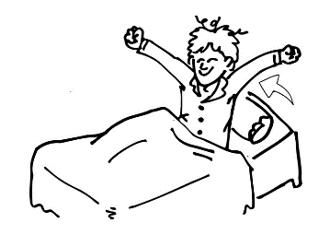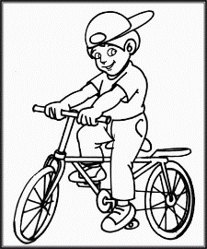

Say (T) or (F)

1. Martin rode his bike last Saturday _____ 6. He had breakfast on Sundays _____

2. He Played volleyball with friends _____ 7. He watched a video. _____

3. He did shopping. _____

4. He got home at 5 o´clock _____

5. On Sundays he got up late _____

Post

Write a travel diary (about 40 words) about a place you visited last year.

* The place you went to
* The things you saw (mountains, lakes, animals,people, etc)
* The things you did

Last year, ________________________________________________________________

_________________________________________________________________________________

_________________________________________________________________________________

_________________________________________________________________________________

Now, Write “X” wherever you consider

( Ahora completa el recuadro con una “X” donde consideres apropiado)

|  |  |  |  |
| --- | --- | --- | --- |
| **Questions?** | **Smiley Face Clip Art at Clker.com - vector clip art online ...YES** | **Okay faceI´M NOT SURE** | **NO** |
| 1. I can write about past events |  |  |  |
| 1. I can write numbers 1-1000 |  |  |  |

